|  |  |
| --- | --- |
| **SquadId** | **SquadName** |
| 8118 | GIANTS Netball |
| 804 | Melbourne Vixens |
| 807 | Queensland Firebirds |
| 801 | Adelaide Thunderbirds |
| 806 | NSW Swifts |
| 8117 | Sunshine Coast Lightning |
| 810 | West Coast Fever |
| 8119 | Collingwood Magpies |

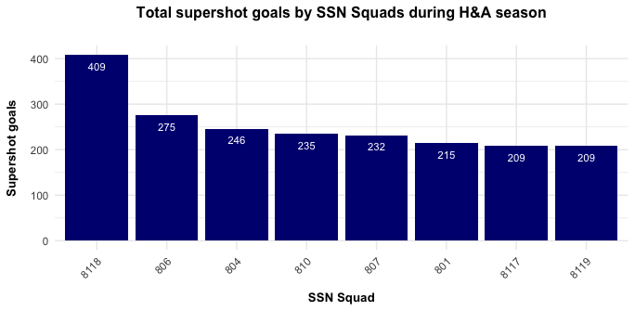

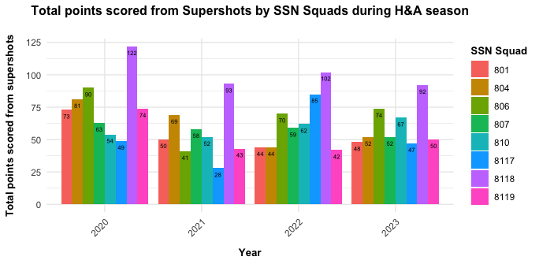

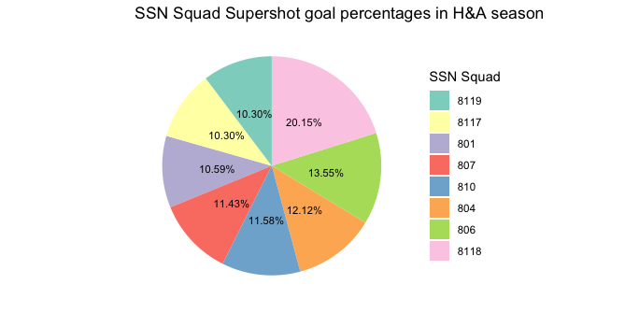

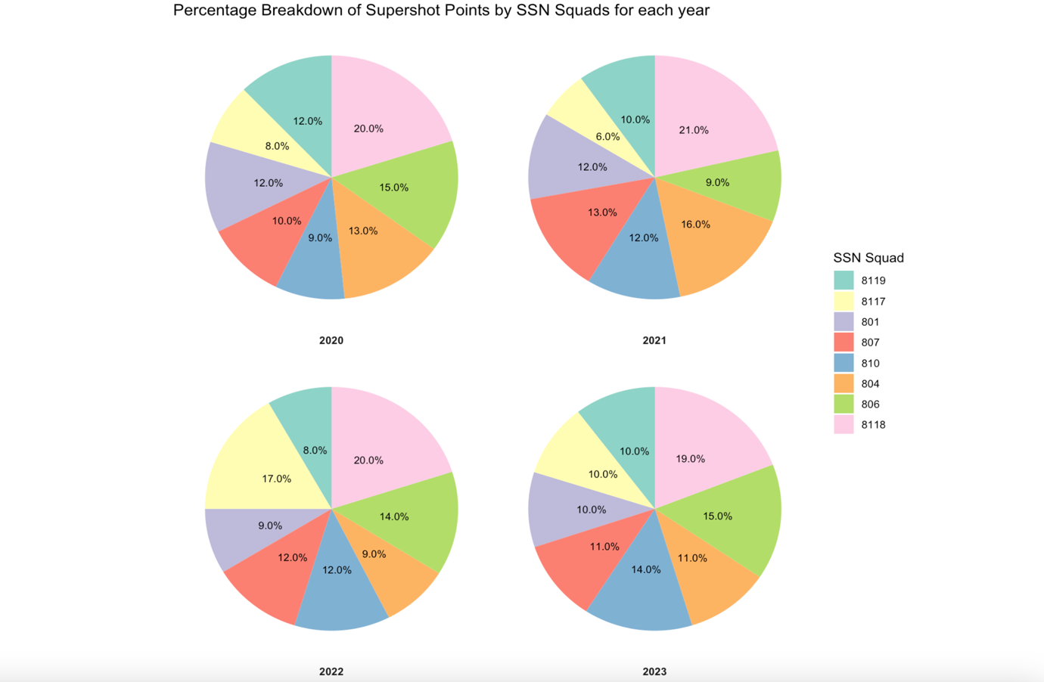

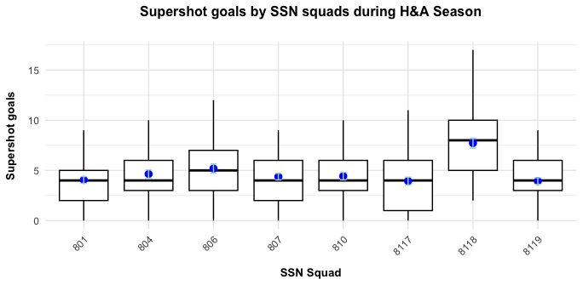

|  |  |  |  |  |  |
| --- | --- | --- | --- | --- | --- |
|  | squadId | Total | Mean | SD | SEM |
| **1** | 801 | 244 | 4.000000 | 2.359378 | 0.3020875 |
| **2** | 804 | 307 | 4.651515 | 2.974209 | 0.3660999 |
| **3** | 806 | 316 | 4.937500 | 3.299230 | 0.4124038 |
| **4** | 807 | 261 | 4.278689 | 2.295874 | 0.2939566 |
| **5** | 810 | 292 | 4.294118 | 2.643261 | 0.3205425 |
| **6** | 8117 | 254 | 3.968750 | 2.817005 | 0.3521256 |
| **7** | 8118 | 485 | 7.348485 | 3.506006 | 0.4315594 |
| **8** | 8119 | 233 | 3.758065 | 2.295294 | 0.2915027 |

|  |  |  |  |  |  |
| --- | --- | --- | --- | --- | --- |
|  | **squadId** | **Total** | **Mean** | **SD** | **SEM** |
| **1** | 2020 | 642 | 5.350000 | 3.247882 | 0.2964897 |
| **2** | 2021 | 482 | 4.016667 | 2.634558 | 0.2405011 |
| **3** | 2022 | 680 | 4.473684 | 2.761963 | 0.2240248 |
| **4** | 2023 | 588 | 4.900000 | 3.247235 | 0.2964307 |

|  |  |  |  |  |  |  |
| --- | --- | --- | --- | --- | --- | --- |
|  | **squadId** | Year | **Total** | **Mean** | **SD** | **SEM** |
| **1** | 801 | 2020 | 73 | 5.214286 | 2.778449 | 0.7425718 |
| **2** | 801 | 2021 | 50 | 3.571429 | 2.408775 | 0.6437722 |
| **3** | 801 | 2022 | 57 | 3.166667 | 1.757338 | 0.4142084 |
| **4** | 801 | 2023 | 64 | 4.266667 | 2.218966 | 0.5729345 |
| **5** | 804 | 2020 | 89 | 5.562500 | 3.999479 | 0.9998698 |
| **6** | 804 | 2021 | 69 | 4.928571 | 2.302650 | 0.6154091 |
| **7** | 804 | 2022 | 88 | 4.190476 | 2.926073 | 0.6385215 |
| **8** | 804 | 2023 | 61 | 4.066667 | 2.250926 | 0.5811865 |
| **9** | 806 | 2020 | 98 | 6.533333 | 3.335238 | 0.8611546 |
| **10** | 806 | 2021 | 50 | 3.125000 | 2.276694 | 0.5691734 |
| **11** | 806 | 2022 | 81 | 4.500000 | 2.727852 | 0.6429609 |
| **12** | 806 | 2023 | 87 | 5.800000 | 3.967727 | 1.0244627 |
| **13** | 807 | 2020 | 63 | 4.500000 | 2.028641 | 0.5421771 |
| **14** | 807 | 2021 | 58 | 4.142857 | 2.597547 | 0.6942238 |
| **15** | 807 | 2022 | 80 | 4.444444 | 2.228749 | 0.5253211 |
| **16** | 807 | 2023 | 60 | 4.000000 | 2.507133 | 0.6473389 |
| **17** | 810 | 2020 | 62 | 3.647059 | 1.998161 | 0.4846252 |
| **18** | 810 | 2021 | 65 | 4.062500 | 2.294014 | 0.5735035 |
| **19** | 810 | 2022 | 82 | 4.100000 | 2.049390 | 0.4582576 |
| **20** | 810 | 2023 | 83 | 5.533333 | 3.907258 | 1.0088497 |
| **21** | 8117 | 2020 | 61 | 3.812500 | 3.059820 | 0.7649551 |
| **22** | 8117 | 2021 | 34 | 2.266667 | 1.980861 | 0.5114561 |
| **23** | 8117 | 2022 | 106 | 5.888889 | 1.640979 | 0.3867823 |
| **24** | 8117 | 2023 | 53 | 3.533333 | 3.226379 | 0.8330476 |
| **25** | 8118 | 2020 | 122 | 8.714286 | 3.851644 | 1.0293953 |
| **26** | 8118 | 2021 | 113 | 6.647059 | 2.737270 | 0.6638855 |
| **27** | 8118 | 2022 | 134 | 6.700000 | 3.743064 | 0.8369745 |
| **28** | 8118 | 2023 | 116 | 7.733333 | 3.534860 | 0.9126970 |
| **29** | 8119 | 2020 | 74 | 5.285714 | 1.540658 | 0.4117581 |
| **30** | 8119 | 2021 | 43 | 3.071429 | 2.129077 | 0.5690196 |
| **31** | 8119 | 2022 | 52 | 2.736842 | 2.329571 | 0.5344402 |
| **32** | 8119 | 2023 | 64 | 4.266667 | 2.250926 | 0.5811865 |

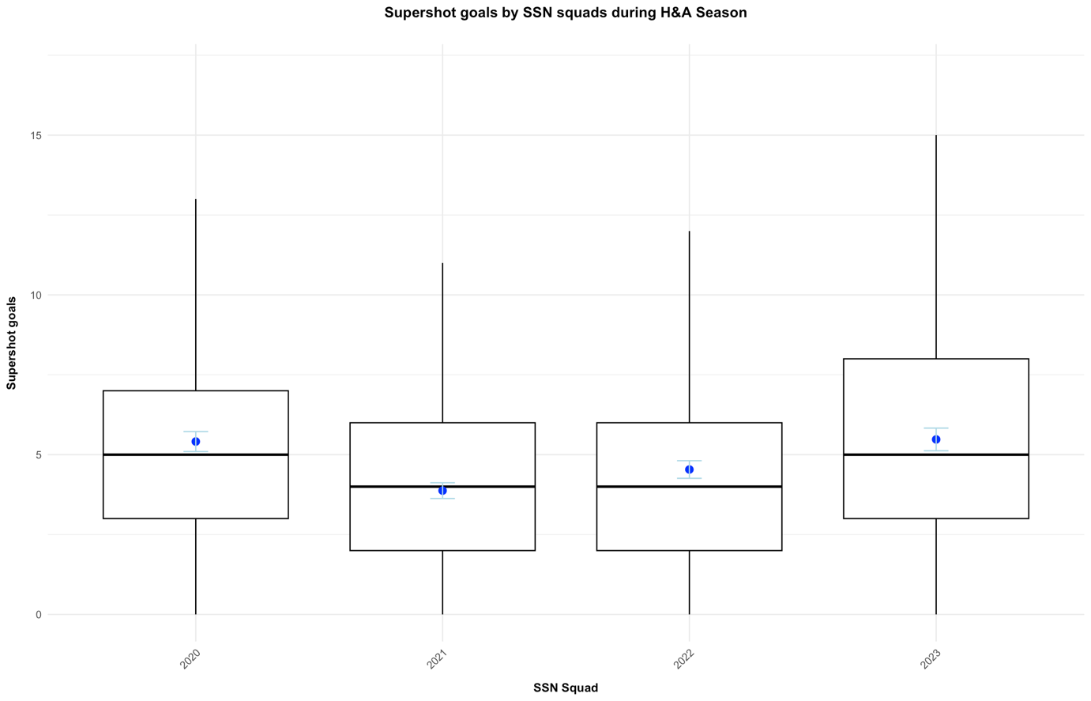

**Summary**